ETL PIPELINE DESIGN FOR CALL CENTRE CUSTOMER SERVICE

A Graduate Project Report submitted to Manipal Academy of Higher Education in partial fulfilment of the requirement for the award of the degree of

BACHELOR OF TECHNOLOGY

In

Electronics and Communication Engineering

Submitted by
Shivam Pathak
Reg. No.: 160907344
Under the guidance of

Joseph Vinod Miranda,  Senior Director,  Data Management,  JLL Technologies | & | Dr. Somashekara Bhat  Professor,  Department of ECE,  MIT Manipal


DEPARTMENT OF ELECTRONICS AND COMMUNICATION ENGINEERING
MANIPAL-56104, KARNATAKA, INDIA

JUNE/JULY 2020


DEPARTMENT OF ELECTRONICS AND COMMUNICATION ENGINEERING
MANIPAL INSTITUTE OF TECHNOLOGY
(A Constituent College of Manipal University)
MANIPAL – 576 104 (KARNATAKA), INDIA

Manipal
19th July, 2020

CERTIFICATE

This is to certify that the project titled “ETL PIPELINE DESIGN FOR CALL CENTRE CUSTOMER SERVICE” is a record of the bonafide work done by SHIVAM PATHAK (Reg. No.: 16090734) submitted in partial fulfilment of the requirements for the award of the Degree of Bachelor of Technology (BTech) in ELECTRONICS AND COMMUNICATION ENGINEERING of Manipal Institute of Technology Manipal, Karnataka, (A Constituent College of Manipal University), during the academic year 2019 - 2020.

Dr. Somashekara Bhat  Professor and Guide,  Department of ECE, MIT, Manipal | & | Dr. M. Sathish Kumar  Professor and Head,  Department of ECE, MIT, Manipal

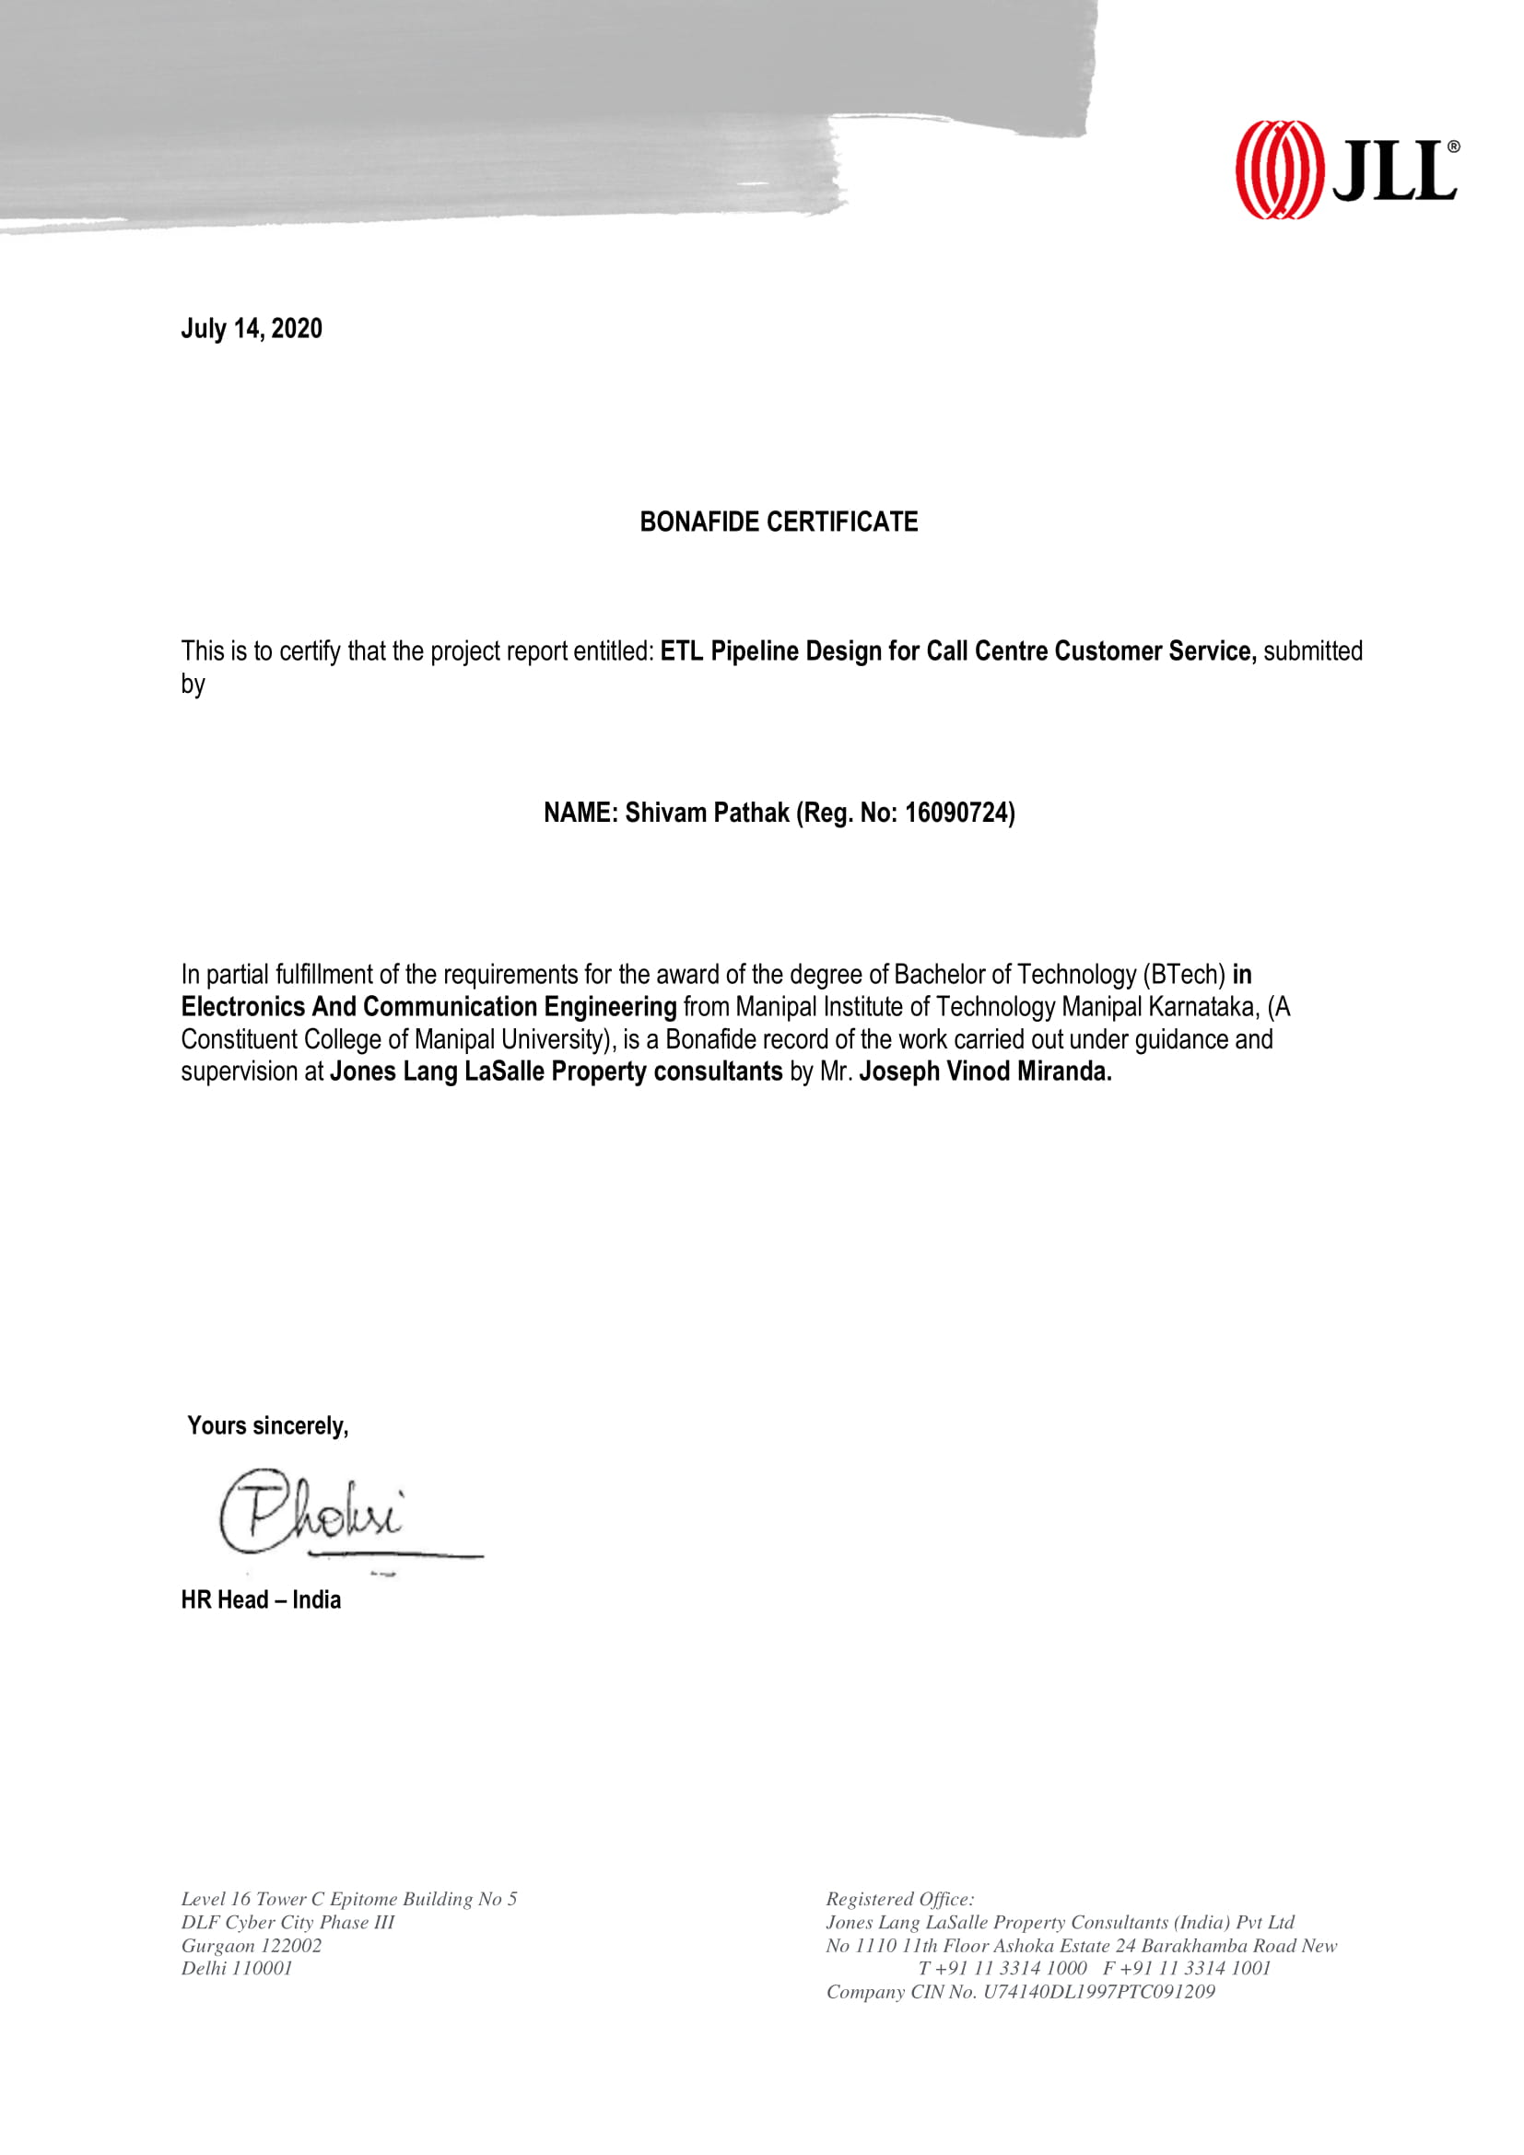
ABSTRACT
JLL is a Real Estate and Asset Management Company with offices in more than 32 countries present across 5 continents on the globe. It has business in multiple ventures, including property management for various companies. If any complaints arise within these properties, an issue is raised to the JLL Call Centers by the property manager, and the issue is handled accordingly. Data is saved at each stage of the process from the beginning until the issue is resolved completely. Data also includes information like total cost involved in each issue, time taken to resolve, net loss/profit.

This data is saved in different formats across the call centers, based on economic, accessibility and IT needs of that country. Furthermore, the raw data of each country is not generally of any use to the Business side of JLL. So, we need to pull data from sources across various call centers and perform ETL (Extract, Transform, Load) operations so that the data can be loaded to any of the data visualization tools and gain insights. Since the data is in different format in different countries, the objective is to design an ETL pipeline to streamline the data accessibility by the business side of JLL.

The project is to make a streamline data flow between two completely different platforms, namely, Altryx and Leverton. Altryx platform is used by US JLL Business team, while the Leverton platform is used by European JLL Business team. In this part, the data is first taken from Altryx Platform and then exported into Python to streamline it and filter out datasets which are required, on the Leverton Platform. Our job is to automate this conversion process so that data transmission can take place fluently. If not, this causes a lot of human error and in turn makes the error unreliable. Automating the process of getting the data from different platforms onto one individual dashboard and furthermore making that dashboard easily accessible to the employees, is the methodology that has been adopted in this project. With all the background information provided by ETL tools and other platforms, designing a working and deployable dashboard is one of the results that this project aims to achieve.

Furthermore, this dashboard also needs to be equipped with the required authorizations to meet the security requirements stated by the organization. The problem statement of the second part of the project is primarily providing required access in the JLL system currently used by the client in order to maintain required security of the system, as well as securing their system to prevent any kind of relevant malpractice. Being secure means having risk-prioritized controls to defend critical assets against known and emerging threats. Companies are increasingly the target of cyber-attacks and subject to demanding regulatory mandates. Secure services help clients establish risk-focused controls around their most sensitive assets, balancing the need to reduce risk, while also enabling productivity, business growth, and cost optimization objectives.
LIST OF FIGURES
Figure No | Figure Title | Page No
2.1 | How the Altryx Platform Works | 4
2.2 | Screenshot of the Altryx Simulation | 5
2.3 | Screenshot of Leverton Platform | 6
2.4 | Identity and Access Management Lifecycle | 9
2.5 | A typical Job to Role Matrix | 10
2.6 | A typical example of Cloud Platform Security | 10
2.7 | Types of ERP system | 12
2.8 | Cloud ERP and On Premise ERP | 12
2.10 | Hybrid ERP | 12
2.11 | Architecture of CO module | 14
2.12 | Working of Materials Management Module | 14
2.13 | Working of Logistics Execution Module | 15
2.14 | Architecture of the User flow | 18
3.1 | Screenshot of importing Python libraries | 21
3.2 | Overall structure of the journey | 22
3.3 | Viewing the JSON file imported from Leverton | 23
3.4 | Example sheet for Leverton Files mapping with Altryx | 23
3.5 | Extracting, transforming and loading the datasets | 24
3.6 | From final table to ready feed table | 24
3.7 | Exporting datasets from python to multiple STG Tables | 25
3.8 | Role Creation Login Pad of SAP | 26
3.9 | PFCG role maintenance | 26
4.1 | Importing datasets from Altryx Platform into Python environment | 28

LIST OF TABLES
Table No | Figure Title | Page No
1.1 | Project Work Schedule | 3

Contents
 |  |  |  |  | Page No
Acknowledgements |  |  |  |  | ii
Abstract |  |  |  |  | iii
List of Figures |  |  |  |  | iv
List of Tables |  |  |  |  | vi
Chapter 1 |  |  | INTRODUCTION
 | 1.1 | Introduction |  |  | 1
 | 1.2 | Motivation |  |  | 2
 | 1.3 | Objective of Work |  |  | 2
Chapter 2 |  |  | BACKGROUND THEORY
 | 2.1 | Introduction |  |  | 4
 | 2.2 | Altryx Basics Leverton Platform Basics |  |  | 4
 | 2.3 | Cloud Basics and Data Warehouse |  |  | 6
 | 2.4 | Identity and Access Management (IAM) |  |  | 9
 | 2.5 | Enterprise resource planning (ERP) |  |  | 11
 | 2.6 | Application Security |  |  | 16
 | 2.7 | Enterprise Application Integration |  |  | 16
Chapter 3 |  |  | METHODOLOGY
 | 3.1 | Introduction |  |  | 20
 | 3.2 | Problem Statement |  |  | 20
 | 3.3 | Tools/Packages Used |  |  | 20
 | 3.4 | Approach |  |  | 22
 | 3.5 | Extracting the data |  |  | 25
 | 3.6 | Integrating with ERP |  |  | 25
Chapter 4 |  |  | RESULT ANALYSIS
 | 4.1 | Introduction |  |  | 28
 | 4.2 | Result |  |  | 28
Chapter 5 |  |  | CONCLUSION AND FUTURE SCOPE
 | 5.1 | Conclusion and Summary of Work |  |  | 30
 | 5.2 | Future Scope of Work |  |  | 30
REFERENCES |  |  |  |  | 32
PROJECT DETAILS |  |  |  |  | 33

CHAPTER 1
INRODUCTION

1.1 Introduction
Data Science is an interdisciplinary field that strives to find meaningful narratives from data. It helps organizations to harness the data and use it to identify new opportunities. This, in turn, leads to smarter business moves, more efficient operations and higher profits. This is done by employing techniques and theories drawn from many fields within the broad areas of mathematics, information science, statistics and. computer science, from the subdomains of machine learning, classification, cluster analysis, uncertainty quantification, computational science, data mining, databases, and visualization.

Although the data itself is most important, what is crucial is the way it is analyzed and utilized in business. With professional expertise, it can turn cutting-edge technology into actionable insights. Today, several organizations and institutions in the Real State Sector are opening their doors to data and Analytics and unlocking its power, thus increasing the value of a data scientist who knows how to drive the value of large amounts of information that already exists inside an institution. Real estate sector has not changed since a long time. Every sector has been using the power of data for the discovery, interpretation, and communication of meaningful patterns. From financial sector to business sector, data is being used everywhere. It also entails applying data patterns towards effective decision making. With an increase in the number of informational events that organizations generate, it becomes challenging for administrators to manage these events and convert them into actionable insights. These insights influence decisions that can have a business impact. JLL Technologies is a client-based service that provides products and third-party products to the Business aspect of JLL. It gathers data from these products (or data sources) and deploys dashboards to detect patterns and insights of a user’s or any other entity. We then process the information to get better insights to be used by JLL Business clients.

At the same time, it is also extremely important to have a secure transmission of data. In order to provide required access in the JLL system currently used by the client and in order to maintain required security of the system to prevent any kind of relevant malpractice., we are using SAP GUI as the primary tool. SAP allows us to custom design all the requirements of the client while keeping intact the integrity of the underlying system by using various modules available. Application Security solutions focus on the integration of security activities throughout the software development lifecycle to enable the design, build, and deployment of secure applications (including SaaS, on-premise packaged, and custom applications).
1.2 Motivation
As mentioned, analytics helps in managing events and information they provide and then provides actionable insights. Business is never profitable all the time, but we make it profitable by helping our Business teams analyze, strategize and implement solution for many challenges that it imposes on us. The design for easy, streamlined and automated flow of information is the crux of both the project. If the flow is not automated and streamlined, different business teams of JLL will face difficulty in analyzing information on a day to day basis. This will affect the ability of the team to serve our clients, thus impacting the overall business.

In addition, to maintain the integrity of the applications on boarded by the organization, we require using SAP modules. In an increasingly digital world, cyber brings new opportunities and threats. Being secure means having risk-prioritized controls to defend critical assets against known and emerging threats. Companies are increasingly the target of cyber-attacks and subject to demanding regulatory mandates. Secure services help clients establish risk-focused controls around their most sensitive assets, balancing the need to reduce risk, while also enabling productivity, business growth, and cost optimization objectives.

1.3 Objective of Work
The following points the important features of the proposed work
• Introduce a certain methodology for the delivery of project.
• Describe the various steps in the selected methodology.
• Illustrate the applications of tools.
• To demonstrate a business application of Data Analytics and deploy the product.

The ultimate objective is to help firm generate revenue through good analytics and data handling. This is done by providing clients Performance Analytics and Operations Analytics. My role is further divided into two parts, which are:
- Part 1: To design an ETL (Extract, Transform, Load) pipeline to streamline the data accessibility by the business side of JLL.
- Part 2: Deploy a streamlined robust and secure system for the flow of data.

1.4 Project Work Schedule

The internship schedule can be distributed into small parts spread out evenly over the period of six months. For each month, some goals have been assigned at the beginning of the internship, and the table 1.1 mentions the same schedule. Furthermore, I would also like to put it out there that the schedule may vary because of various reasons and thus this table is subject to change.

Table 1.1 – Project Work Schedule
January 2020 | - Onboarding by the company.  - Learning about various Business aspects of JLL.  - Learn about the various teams of JLL Tech.
February 2020 | - Get a glimpse of all the teams in JLL tech by interactive sessions.  - Learn about different software’s used by JLL Tech.
March 2020 | - Building a prototype to compare Altryx Model currently used by the company with Python Programming.
April 2020 | - Uploading data into visualization tools to get better insights of the data.  - Designing API for GPO Insight.
May 2020 | - Identify python libraries that can help the transition data from Altryx to Leverton Platform.  - Building a Dashboard with Python  - Tweaking the Dashboards of the visualization tools according to the Business needs.
June 2020 | - Encryption of the data for secure transmission  - Innovation project about Artificial Intelligence in Data Handling

CHAPTER 2
BACKGROUND THEORY

2.1 Introduction
This chapter will give a better insight on various tools which are used for the deployment of the project. It includes a basic introduction to Altryx and Leverton Platforms, basic introduction to Cloud Service, and the strategy used for streamlining the data from one platform to another. It also discusses the Identity Access Management (IAM), as one of the core concepts of Cyber Security, Enterprise Resource Planning (ERP) and its types, why did we use SAP as the ERP and various modules of SAP.

2.2 Altryx and Leverton Basics
To get a better understanding of how to properly leverage a machine’s resources to use Alteryx, it can be very helpful to understand how the Alteryx Engine functions. To clear up any haziness surrounding the term “Alteryx Engine”, this part cover what happens when we click the run button. When a command is in run, it processes how much Memory and RAM is required. The first thing to note is the difference between Disk and RAM. Executing processes is slower when done on Disk than when on RAM. With that in mind, the Engine will try to do its processing in RAM after it reads data from a Disk one record at a time. The Fig 2.1 shows the general flow of records through a altryx workflow simulation. (Blue is on Disk, Red is in RAM)


Fig 2.1 Block diagram of Altryx Platform (Courtesy [1])

One Record is read from Disk to RAM, then moved into the Formula tool before being released back to Disk in the Browse tool. Once this is complete, then the Engine will move onto Record 2 and so on. On the other hand, the Sort/Join processes are used by the Sort and Join Tools, as well as other tools, which are called Blocking tools. Blocking Tools require that all records are read into the tool before more processing can be done. With the base knowledge and understanding of how the Engine works, we can better leverage our machine’s resources and understand why certain processes might be taking longer than expected. Better specs = better Alteryx-ing = better data solving![1] In Fig 2.2, the screenshot of the Altryx Platform is attached to get a better understanding of how the simulation in Altryx Platform works.
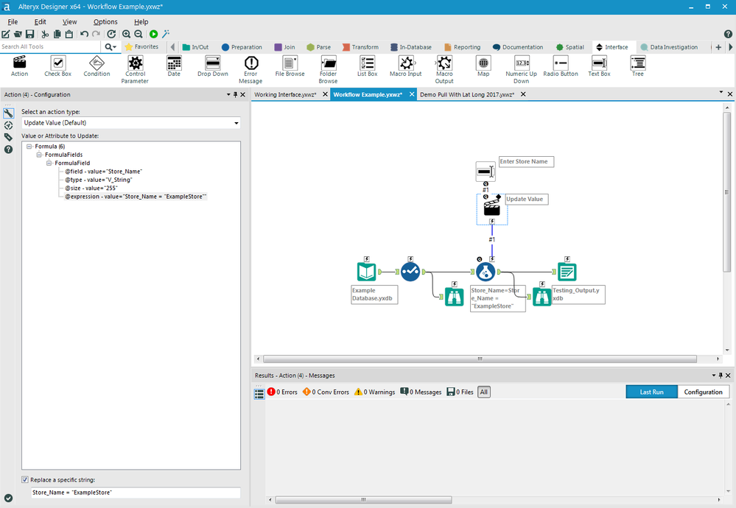

Fig 2.2 Screenshot of Altryx Simulation (Courtesy [1])

Leverton is an AI-driven information extraction and management platform that leverages machine learning technology to automate the process of document management by creating structured data out of unstructured documents, enabling smarter and data-driven decisions for clients. This is one of the core client platforms used in the field of Real Estate Data Management.

Leverton provides teams with a ‘core’ of structured company data regardless of their size or scale, as all organizations work with legal documents. Its use cases range from large real estate due diligence processes and ongoing data and document management, to the facilitation of new accounting standards such as IFRS 16/ US GAAP ASC 842 and beyond.

From an accountant’s perspective, their activities can be divided into creative tasks i.e. analysis of data and uncreative tasks such as identification and classification of information from lease documents. The uncreative tasks usually take up much of their time, requiring a high degree of concentration and can often lead to potentially costly errors. Furthermore, as the process of data extraction is done manually, the scope for data analysis is often restricted, leading to sub-optimal and costly decision-making based on incomplete data.This is where automation of data extraction comes as a real game-changer for accountants, who can now spend more time analyzing extracted data and providing better services to clients instead of being bogged down by mundane paperwork.

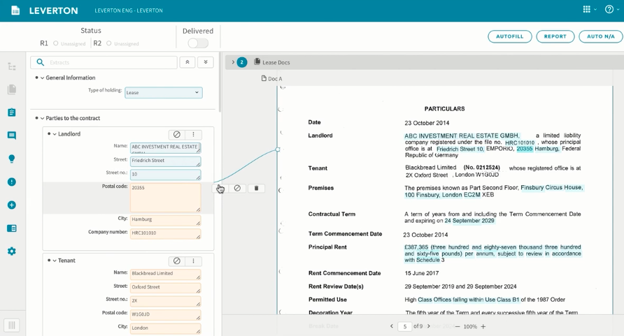
Leverton’s deep learning platform is ideal for simplifying the transition to the new lease accounting standards through automated data extraction. The artificially intelligent technology gathers all leasing documents into a single platform, automatically categorizes them and extracts all relevant information from leases. Once in a structured format, the extracted lease information can be imported into the companies’ preferred target systems such as lease management systems, saving both time and costs. The fig 2.3 shows a screenshot of the Leverton Platform to get a better understanding of the Leverton Platform.[2]

Fig 2.3 Screenshot of Leverton Platform (Courtesy [2])

2.3 Cloud Basics
The data is processed, transformed, and ingested so that users can access the processed data in the Data Warehouse through Business Intelligence tools, SQL clients and flat files (including txt, excel and csv files). The data warehouse is used in such a way that it merges information coming from different sources into databases as needed by the business teams at JLL.
I have leveraged informatica cloud tools for this project. Informatica Cloud is a data integration solution and platform that works like Software as a Service (SaaS). It integrates cloud-based data with the data residing in on-premise databases and systems or between cloud applications.
Informatica Cloud Data Integration is the cloud-based Power Center which delivers accessible, trusted, and secure data to facilitate more valuable business decisions.[3]

If we are using a cloud data warehouse like AWS Redshift, Azure SQL Data Warehouse, or Snowflake, we can use Informatica Cloud Data Integration solutions to help improve the overall performance, productivity, and extensive connectivity to cloud and on-premises sources.[4]

Informatica Cloud can connect to on-premises and cloud-based applications (like Salesforce, Marketo, NetSuite, Workday) databases, flat files, file feeds, and social networking sites.[5]

2.3.1 Data Warehouse
Data warehouse and Data lake are two terms that one comes across a lot whilst dealing with a large amount of data. Data Warehousing is the process of collecting and managing data from various services/sources. It’s a system used for reporting and data analysis processes and is considered as one of the core components of Business Intelligence. It is typically used to collect and analyse business data from heterogenous sources. It is a blend of technologies and components which aids the strategic use of data. It is electronic storage of a large amount of information by a business which is designed for query and analysis instead of transaction processing. It is a process of transforming data into information and making it available to users in a timely manner to make a difference.

A Data Warehouse works as a central repository where information arrives from one or more data sources. Data flows into a data warehouse from the transactional system and other relational databases.

2.3.2 Structured Data
Structured data refers to any data that resides in a fixed field within a record or file. This includes data contained in relational databases and spreadsheets. Basically, any data which has a certain pattern to it is called structured data.

JSON is one of the basic and most commonly used structured data. JSON stands for JavaScript Object Notation. As the name implies, it’s based on the way you define objects and arrays. It is a simple, text-based way to store and transmit structured data. It is one of the most important flat files which is used to store structured data. By using a simple syntax, we can easily store anything from a single number through to strings, arrays, and objects, using nothing but a string of plain text. We can also nest arrays and objects, allowing you to create complex data structures. Once we have created the JSON string, it’s easy to send it to another application or computer, because it’s just plain text. The following example shows how we might store a simple shopping cart in JSON format:
{
"orderID": 12345,
"shopperName": "John Smith",
"contents": [
{
"productID": 34,
"productName": "SuperWidget",
"quantity": 1
},
{
"productID": 56,
"productName": "WonderWidget",
"quantity": 3
}
{
"productID": 27,
"productName": "MediumWidget",
"quantity": 3
}
],
"orderCompleted": true
}

2.3.3 Semi-structured Data
Semi-structured data is the data which does not conforms to a data model but has some structure. It lacks a fixed or rigid schema. It is the data that does not reside in a rational database but that have some organisational properties that make it easier to analyse. With some process, we can store them in the relational database.

2.3.4 Unstructured data
The phrase unstructured data usually refers to information that doesn't reside in a traditional row-column database. As you might expect, it's the opposite of structured data — the data stored in fields in a database. Unstructured data files often include text and multimedia content. Examples include e-mail messages, word processing documents, videos, photos, audio files, presentations, webpages and many other kinds of business documents which cannot be put in a structured form.

2.4 Identity and Access Management (IAM)
Identity and Access Management (IAM) is one of the core concepts of Cyber Security. It is a discipline that enables the right person to access the right resources and information at the right time. It addresses the requirement to ensure appropriate access to resources across increasingly heterogeneous technology environments and to meet increasingly rigorous compliance requirements. There are several technologies used to control and use IAM. Application Integrity is the aspect in which all applications on boarded on the client site are secured. A critical part of any system is that its applications which are deployed perform correctly; with integrity. In fig 2.4, the lifecycle of Identity and Management is shown. It is imperative to realize that application integrity can be accidentally cracked: libraries or executable files may be changed or deleted, which will cause the application to malfunction. Technologies used to handle Application Integrity are Oracle, UI Path, SAP, among many.

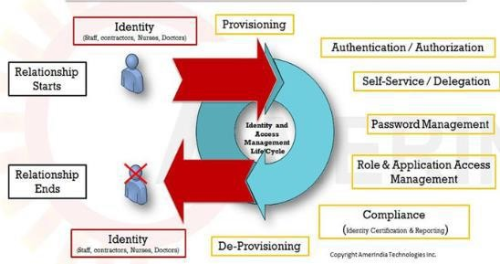

Fig 2.4 Identity and Access Management Lifecycle (Courtesy [6])

The business process teams are responsible for developing the new business design as part of the overall process redesign. At the end of this phase they will have developed a list of business process flows and information about the ERP solution with related activities and master data, but they will also have developed a list of associated ‘roles. To simplify, a role is the part an employee plays in completing work and is a subset of tasks (system and non-system) carried out by a job. As shown in figure 2.5, role mapping defines how roles are connected to process activities and which roles are connected to what people (and jobs) in the ‘to-be’ organization. Role Mapping results in the assignment of security roles and other user-specific settings to the employees that will use the ERP system being deployed. It is also a critical input into the key step of developing a training curriculum based on the roles that have been developed and the development of training content.
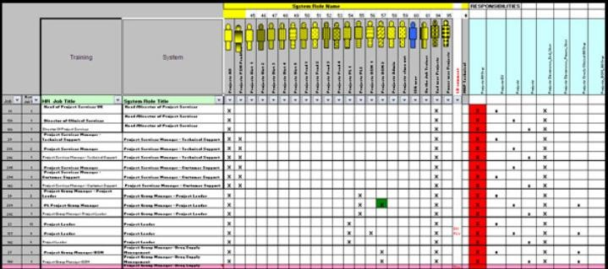
Fig 2.5 A typical Job to Role Matrix (Courtesy [6])

The main objectives of Identity and Access Management are to ensure that only valid parties have the right accesses to the right resources at the right time, while keeping illegitimate parties at bay. As can be understood by the image in fig 2.6. Various parties, including the organization employees, the contractors, its vendors, its clients, and even devices, require access to systems and as such need the establishment of their identities and assigned access rights. Often, parties having system access become targets of identity theft by hackers who need these access privileges to gain access to the systems.

Fig 2.6 A typical example of Cloud Platform Security (Courtesy [8])
Its objectives ensure the elimination of access as soon as employment is terminated and monitoring of activities to sense hacking attempts or unauthorized activities in order to protect systems and information. IAM practices automate system monitoring based on predetermined benchmarks to detect fraudulent transactions. To ensure the above regulatory and security requirements are met one needs to understand the working to the organization installing the ERP system, hence role mapping is important. “When considering that the users’ inability to protect and manage passwords causes over 90% of cyber-attacks, it is evident that our current IAM approach which mostly uses passwords for authentication cannot support the security of the future state where many devices will be interconnected” says Henry Bagdasarian, founder of Identity Management Institute and cybersecurity thought leader.[7] It postulates that IAM will expand beyond humans, pets, and other living things to include identities of robots and smart devices. Anything that needs to be connected to something for data sharing and automated tasks will be connected to make human lives easier, collaborative, and more productive. As distributed and interconnected systems increase in numbers, seamless, continuous, and accurate access to all resources with advanced authentication systems such as biometric and artificial intelligence technology will be prevalent. Passwords will be a thing of the past as user-controlled access will be replaced by machine-controlled access management.
There will be no more passwords to access systems or badges to enter buildings. Smart systems will be able to recognize and greet us using some of our personal and distinct features when we use ATMs, enter stores and restaurants, visit online websites, enter office locations, drive cars, and access business systems.

Identity management and artificial intelligence will revolutionize security beyond people, places, and things that we manage today as increasing number of devices and systems will communicate with and learn from one another without human intervention. Almost everything will have an identity which will change today’s definition of identity theft.

2.5 Enterprise resource planning (ERP)
Enterprise resource planning (ERP) is integrated to the management of main business processes, often in real time and mediated by software and technology. ERP provides an integrated and continuously updated view of core business processes using common databases maintained by a database management system. ERP is usually referred to as a category of business management software — typically a suite of integrated applications—that an organization can use to collect, store, manage, and interpret data from many business activities. ERP systems track business resources and the status of business commitments: orders, purchase orders, and payroll. that provide the data. ERP facilitates information flow between all business functions and manages connections to outside stakeholders. The applications that make up the system share data across various teams and departments.
2.5.1 Benefits of ERP System
- Higher productivity –It streamlines and automates the core business processes to help everyone in the organization to do more with fewer resources.
- Better insights - Eliminate information silos and gain a single source of truth.
- Accelerated reporting - Fast-track business and data reporting and securely deploy results. Act on insights and improve performance in real time.
- Lower risk - Maximize business visibility and control, ensure compliance with regulatory requirements and predict and prevent risk.
- Improved agility - With efficient operations and ready access to real-time data, we can quickly identify any key problems.

2.5.2 Types of EPR
The types of ERP can be classified depending on the use case of the system, the type of system, the scale of the system etc. Broadly we can classify depending on the type of system.
 |  |  | ERP
Cloud ERP  In this type of system where most of the data is stored online on cloud |  |  | On-Premise ERP  In this type of system, the data is stored and the system is hosted on local servers. |  |  | Hybrid ERP  This type of system is a combination of cloud and on-premise ERP


Fig 2.7 Types of ERP system (Courtesy [7])


Figure 2.8 – Cloud ERP Figure 2.9 – On Premise ERP Figure 2.10 – Hybrid ERP

2.5.3 What is SAP?
There are multiple companies that offer ERP solutions, some of them offer industry specific like HR, Finance, operations etc whereas the big players offer a complete set of system which can accommodate all the different functions(modules) in a single solution.
We have used SAP for deploying our EPR presentation. SAP stands for applications of systems and products. SAP is a market leader in Enterprise Resource Planning (ERP) solutions and services. SAP ERP software products provide powerful tools to help businesses manage their finances, logistics, human resources, operations and other areas of business. The heart of the SAP software offering is the SAP ERP system, which is the most advanced Enterprise Resource Planning (ERP) system among those currently available. Enterprise Resource Planning (ERP) is software designed for organizations in different industrial sectors, regardless of size and power. The ERP package is designed to support and integrate almost all functional areas of a business process, such as purchasing goods and services, sales and distribution, finance, accounting, human resources, manufacturing, production planning, logistics and warehouse management. The SAP system includes several fully integrated modules that cover virtually every aspect of business management.[8]

2.5.4 How is SAP unique?
SAP has successfully captured more than 60% of the market and most the fortune 500 companies rely on SAP ERP solutions to carry out their daily functions. There many reasons which make SAP the market leader in the field of ERP solutions. Some of the factors are listed below.

- Highly Integrable - SAP provides easy integrating options in which SAP ERP can accommodate different software easily.
- Single entry Point - It is very much secure as it has only single-entry point and cannot be easily hacked. It supports features like encryption.
- ASAP - ASAP Methodology is often known as “Accelerated SAP” is a standard SAP related Project preparation and implementation method. This methodology is developed and updated by the consultants who are in involved in implementing SAP software products. This methodology is also equally useful for the project managers and other individuals who are into implementing systems which cater to business support processes.
- SAP Modules - SAP solutions include several functional modules, which support transactions to execute key business processes [8], such as –

  - Controlling (CO) – As can be seen in fig 2.10, SAP CO (Controlling) module facilitates coordinating, monitoring, and optimizing all the processes in an organization. It controls the business flow in an organization. This module helps in analyzing the actual figures with the planned data and in planning business strategies.
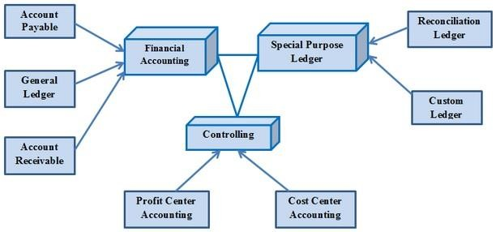
Fig 2.11 Architecture of CO module (Courtesy [8])

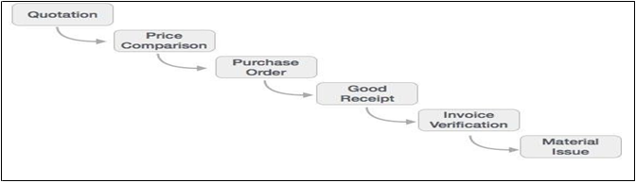
  - Materials Management (MM) – As can be refereed from the fig 2.11, material Management deals with movement of materials via other modules like logistics, supply chain management, sales and delivery, warehouse management, production and planning.
Fig 2.12 Working of Materials Management Module (Courtesy [8])

  - Logistics Execution (LE) - Logistic Execution can be divided into two sub-modules, i.e., shipment of goods (purchase to procurement process) and warehouse management (storage of goods), as shown in fig 2.11. These two modules are integrated with sale and distribution, material management, and production and planning.
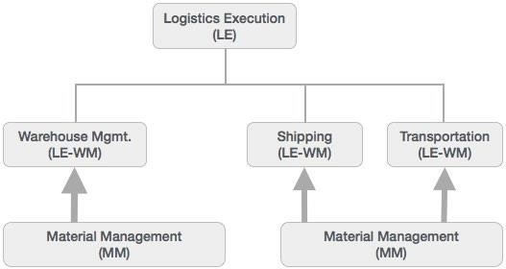
Fig 2.13 Working of Logistics Execution Module (Courtesy [8])

  - Supply Chain Management (SRM) - As the name SRM suggests, this module deals with the effective and efficient transition of products and services between an organization and its suppliers. The main process covered in this section is procurement of products like direct materials, indirect materials, and services. This module can effectively integrate with planning, accounting, and inventory system.
  - SAP Basis Modules - Basis is a set of programs and tools that act as an interface with Database, Operating system, Communication protocols and business applications (such as FI, CO, MM etc.). Full form of BASIS is "Business Application Software Integrated solution" SAP applications such as FI, CO, PP etc. can run and communicate with each other across different Operating systems and Databases with the help of BASIS. We can say Basis is the operating system for SAP applications and ABAP. Basis provides services like communication with the operating system, database communication, memory management, runtime collection of application data, web requests, exchanging business data etc.
  - Customer Relationship Management (CRM) - CRM deals with end-to-end customer related processes. CRM is designed to centralize the data related to all the customers associated with an organization.[9]

2.6 Application Security
In the recent years, application security has been viewed in as the securing of the web application layer from attacks by unauthorized users [10]. These vulnerabilities exist in the web application layer due to the usage of an unsuitable software development model that guides the development process. Thus, this literature review[10] was conducted in order to investigate the several vulnerabilities that are used to secure the web application layer, the security approaches or systems used in the process, the phases in the software development in which these techniques are highlighted, and the various tools and mechanisms utilized to detect the vulnerabilities. This study was used to extract 519 publications from respectable scientific sources, such as the IEEE Computer Society, ACM Digital Library, Science Direct, and Springer Link. They performed a deep analysis on the application security vulnerabilities detection methods which helped them identify the scope of SLR for comprehensive investigation for future research. OWASP was the major source of construction and validation of web security processes and standards.

Today’s rapidly changing business environment presents multiple data alignment challenges. Cloud adoption, mergers and acquisitions, reorganizations and restructuring can create data inconsistencies that require teams to reconcile disparate data sets and associated metadata. Changes to application metadata, dimensions, hierarchies, mappings and related attributes are often handled manually through spreadsheets, email, and in-person meetings. To help finance leaders eliminate manual errors and inconsistencies, create a single view of all enterprise data, and realize their vision for front and back-office business transformation, Oracle Enterprise Data Management Cloud provides centralized, self-service enterprise data maintenance, and data sharing and rationalization.

As organizations grow and evolve, business and finance leaders face an increasingly complex range of challenges in managing and governing their enterprise data assets that cannot be successfully addressed through traditional approaches. With SAP Enterprise Data Management Cloud, there is a modern platform that streamlines business transformation efforts and enables organizations to maintain data integrity, accuracy and consistency across all their applications – in the cloud and on-premises.

2.7 Enterprise Application Integration
Enterprise Application Integration is an integration framework composed of a collection of technologies and services which form a middleware or "middleware framework" to enable integration of systems and applications across an enterprise. Many types of business software such as Client Data Portal, Customer Relation Application, Real Estate Data Portal, Market link and financial applications typically cannot communicate with one another in order to share data or business rules.[11] This lack of communication leads to inefficiencies, wherein identical data are stored in multiple locations, or straightforward processes are unable to be automated.
    - JLL Authorization Concept
The JLL authorization concept protects transactions, programs, and services in JLL systems from unauthorized access. Based on the authorization concept, the administrator assigns authorizations to the users that determine which actions a user can execute in the JLL System. To execute transactions in the name of the organization, a JLL user requires corresponding authorizations, as business objects or transactions are protected by authorization objects. The authorizations represent instances of generic authorization objects and are defined depending on the activity and responsibilities of the employee. The authorizations are combined in an authorization profile that is associated with a role. User administrators then assign the corresponding roles using the user master record, so that the user can use the appropriate transactions for his or her tasks.

- Transaction - A transaction code is a command to execute a function in the JLL system by typing it in command field in a single step, instead of navigating through menu path. A transaction code consists of letters, numbers, or both. It is used to capture a business task that consists sequences of screen and generates JLL documents with various functions of create, change and display.
- Authorization Objects - Authorization Objects are templates upon which authorizations are being built upon. An authorization object allows complex tests of an Authorization for multiple conditions. For an authorization check to be successful, all field values of the authorization object must be maintained in the user master.
- Profile - User authorizations are not usually assigned directly to user master records but grouped together in authorization profiles. Authorizations can be collected in authorization profiles to reduce the maintenance effort which would be required to enter individual authorizations in the user master record. They contain specific access rights, identified by an object name and a corresponding authorization name. Profile changes only take effect when the user next logs on. Users who are logged on when the change takes place are not affected in their current session.
- Roles – JLL Roles are defined as collections of certain activities used in different business scenarios. In business each user is assigned with some activities and restricted to others to ensure that business data is always secure. To complete these assigned activities users, need to access the different JLL transactions, reports, or Web-based applications in the JLL system. Role can be either assigned from JLL predefined roles or a new role can be created to meet the client's specific requirement.
- User - User ids allow access to JLL applications. Each user must have a corresponding profile specifically assigned. In many situations, multiple composite profiles can be assigned to a user ID, depending on the role(s) an individual user is responsible for, in the business processes. These enable the user to log onto the JLL System and allow access to the functions and objects in it within the limits of the specified authorization profiles. Changes only take effect when the user next logs on. Users who are logged on when the change takes place are not affected in their current session.
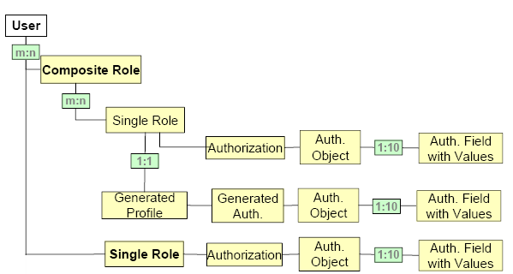
Fig 2.14 Architecture of the User flow (Courtesy [11])

2.8 Innovation Project
During the end of the internship, since the project got stalled because of COVID 19, I have been given another project where I am asked to present to the team members about how to Balance Ethics and Technological Advancement in the Age of Data And AI. I have decided to add that part in the report in brief.

A growing number of companies see AI as critical to their future. But concerns about possible misuse of the technology are on the rise. In a recent survey conducted by one of the leading Auditing Firms in the world, Deloitte, 76 percent of executives said they expected AI to “substantially transform” their companies within three years, while about a third of respondents named ethical risks as one of the top three concerns about the technology. The press has widely reported incidents in which AI has been misused or had unintended consequences.

The conversation about responsible AI is hardly limited to concerns about controversial applications of the technology, such as automated weapons. It also considers how the infusion of AI into common activities such as social media interactions, credit decisions, and hiring can be controlled to avoid unintended or adverse outcomes for individuals and businesses. The discussion around AI and ethics has grown far more urgent in the last decade or so, and many initiatives to tackle ethical questions surrounding AI have taken shape in the last couple of years.

This is primarily driven by recent advancements in AI technologies, growing adoption, and increasing criticality of AI in business decision-making. It’s worth noting that concerns about the ethics of technology generally and AI specifically are nothing new. The topic was explored at least as far back as 1942 when science-fiction writer Isaac Asimov introduced his Three Laws of Robotics in a short story. In 1976, a German American computer scientist suggested that AI technology should not be used to replace people in positions that require abilities such as compassion, intuition, and creativity. Still, today’s AI presents enormous opportunities for businesses while introducing some novel risks that need to be managed.

We see an increase in the use AI in various industries like financial markets, Pharma, FMCG, manufacturing etc. but AI is set to take a major role in the Real Estate Market.

AI is on its way to becoming mainstream in Commercial Real Estate services within a short amount of period. Most of the adoption of AI will be in the following use cases-
• Generating new revenue potential
• Risk Management
• Process re-engineering and automation
• Customer service
• Customer acquisition

CHAPTER 3
METHODOLOGY

3.1 Introduction
This chapter first clearly defines the problem statement. Once a concrete understanding is established regarding the requirements and reason for doing this project are explained. After this Methodology is explained for the report in detail. Each phase in the process is clearly explained along with the reasons for using the approach.

3.2 Problem Statement
Agenda for the project is to take the Altryx data, make a robust and diligent pipeline solution through ETL process, so that it is ‘ready data’, which can be further distributed to various downstream application.

Target Statement for the security aspect of the data is the importance of the result obtained from the implementation of IAM and application security.

3.3 Tools/Packages Used

Several tools and software have been used for extracting required data, automating the tagging process and designing the Dashboard:

Altryx Platfrom for extracting Data.

Leverton Platform for Extracting/ Transferring data.

Jupyter Notebooks: The coding for the ‘ETL’ process is done in Jupyter notebooks using Python Language.

Command Prompt: To run the script on Python, several functions are required. Python, being an open source, has plenty of libraries that host functions which have been helpful in scripting of the code required to design an interactive Dashboard. Command Prompt is used to install the required libraries.

JSON Files: The data extracted from Altryx Platform is stored in the form of JSON flat files, which are then imported into Juypter notebooks for conversion into Python Dataframes.

Flat Files – All the Dataframes in Python undergo an ETL (Extract, transform, load) process and are converted into three kinds of flat files, viz CSV, excel and text file.

CSV files – Comma separated files are the most famous and commonly used flat files which is used in Data analytics.

3.3.1 Python Packages needed for the project
As mentioned before, to run the script on Python, several functions are required. Python, being an open source, has plenty of libraries that host functions which have been helpful.
- Pandas: Pandas is the most widely used tool for data wrangling. It contains high-level data structures and manipulation tools designed to make data analysis fast and easy. DataFrame and, Reading and Writing into CSV files are one of major functions used in the project.
- Numpy: NumPy, which stands for Numerical Python, is a library consisting of multidimensional array objects and a collection of routines for processing those arrays. Using NumPy, mathematical and logical operations on arrays can be performed. This tutorial explains the basics of NumPy such as its architecture and environment. It also discusses the various array functions, types of indexing, etc. An introduction to Matplotlib is also provided. All this is explained with the help of examples for better understanding.
- Pandas System: The sys module provides functions and variables used to manipulate different parts of the Python runtime environment.
- CSV: The so-called CSV (Comma Separated Values) format is the most common import and export format for spreadsheets and databases. The csv module implements classes to read and write tabular data in CSV format. It allows programmers to say, “write this data in the format preferred by Excel,” or “read data from this file which was generated by Excel,” without knowing the precise details of the CSV format used by Excel. Programmers can also describe the CSV formats understood by other applications or define their own special-purpose CSV formats.
- Import Operating System(os): This module provides a portable way of using operating system dependent functionality. If you just want to read or write a file see open(), if you want to manipulate paths, see the os.path module, and if you want to read all the lines in all the files on the command line see the fileinput module. For creating temporary files and directories see the tempfile module, and for high-level file and directory handling see the shutil module.

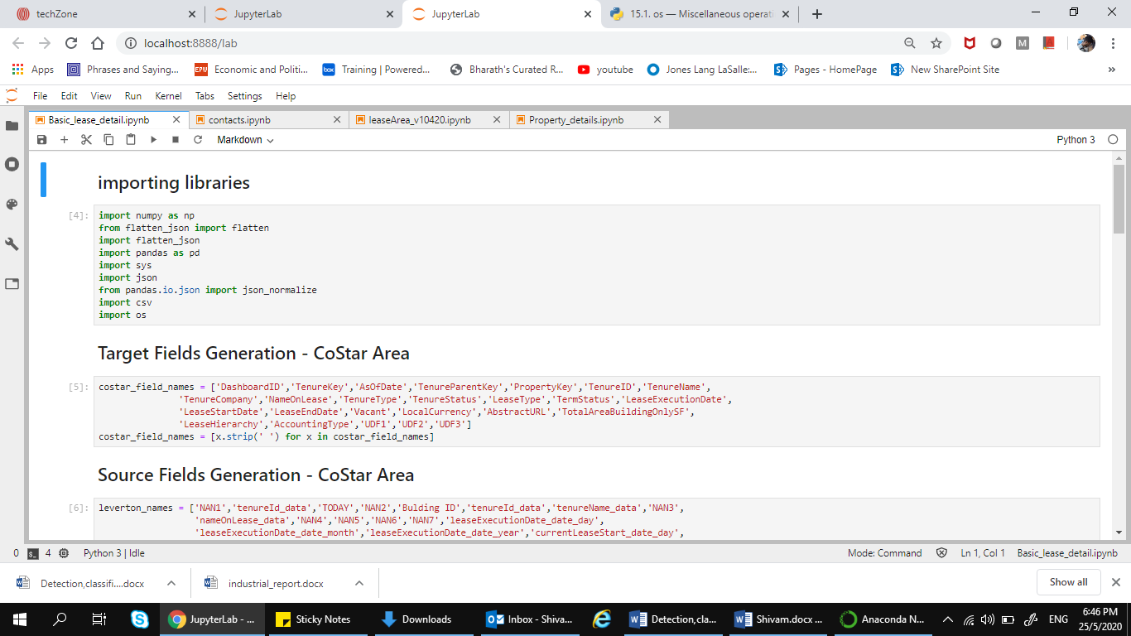
In the Fig 3.1, I have taken a screenshot of all basic tools I have used while converting the data from Altryx Platform to Leverton Platform. The libraries ran in a Jupyter notebook on the Anaconda’s Platform.

Fig 3.1 Screenshot of importing Python libraries
3.4 Assumptions taken during the Project
- Leverton XML file will be always be similar with respect to its structure.
- Informatica Cloud process will be leveraged to convert JSON as it is.
- XQuery will be leveraged as is and will be executed by Informatica Cloud.
- Informatica Cloud process will be releasing JSON file after processing XML through XQuery.
- Stored Procedures will be leveraged and incorporated in below proposed plan to introduce business logics.

3.5 Approach
My approach is as follows:
- Convert the JSON file provided by Leverton into a flat file/ CSV file.
- Load data from flat/CSV file to STG table (One to One mapping).
- Process STG Table data by respective Stored Procedure (Built already and being use by Portfolio).
- Load processed data into final target tables.
- Create a delta cut from this data as per CoStart requirement.
- Transmission of delta file to CoStar end point.

3.5.1 Leverton XML to JSON Files
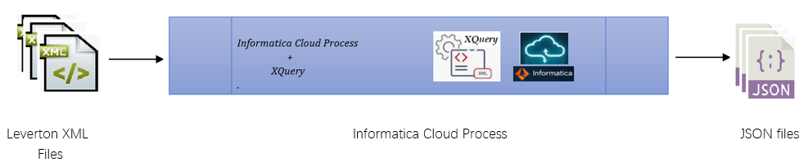
This process is already existing with the team at JLL Technologies and it will be used in the similar way. The only adjustment is to make it reusable and adjust the code to fit the flow to get the required tweaks. The Fig 3.2 shows the flow diagram of the existing process, which is currently used, which is further going to be leveraged by the team in the ETL (Extract, transform, load) process.
Fig 3.2 Overall structure of the journey
3.5.2 JSON files to Final Target Tables
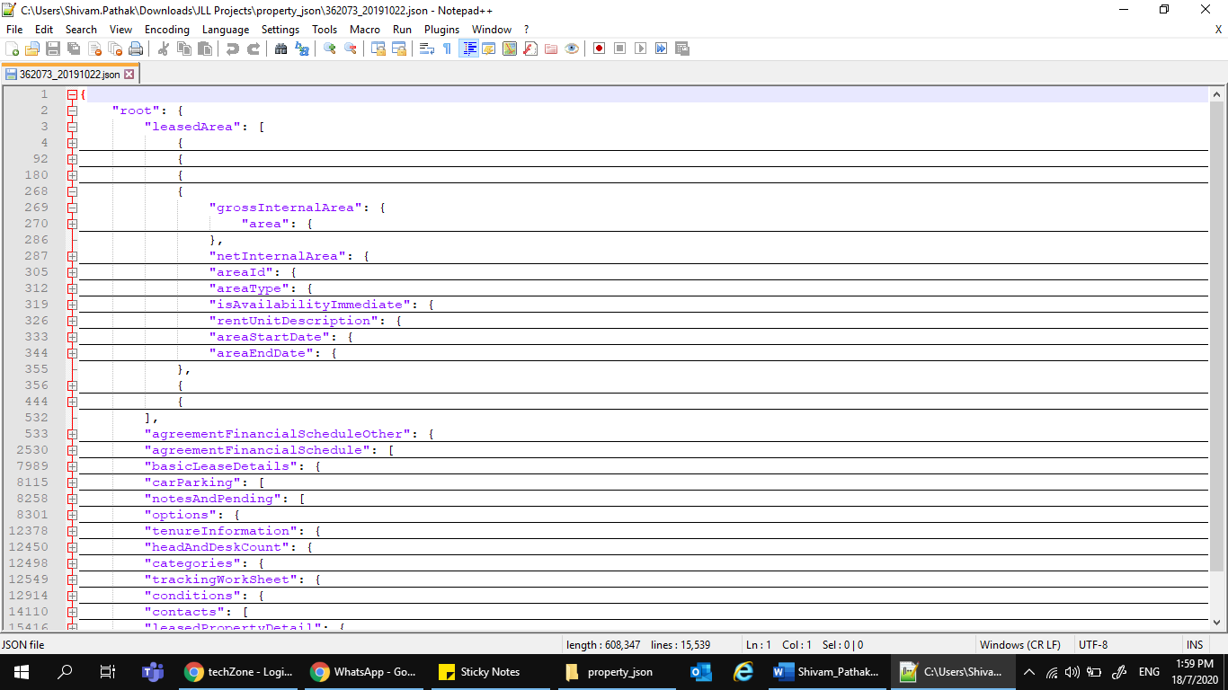
In this process, JSON files will be processed and loaded to final target tables, and it will be ready to feed for the downstream applications. As can be seen in the fig 3.3, JSON file is imported and read. We also receive a mapping sheet (in excel format) which maps the columns and tables of Leveton to that of the JSON file.

Fig 3.3 Viewing the JSON file imported from Leverton

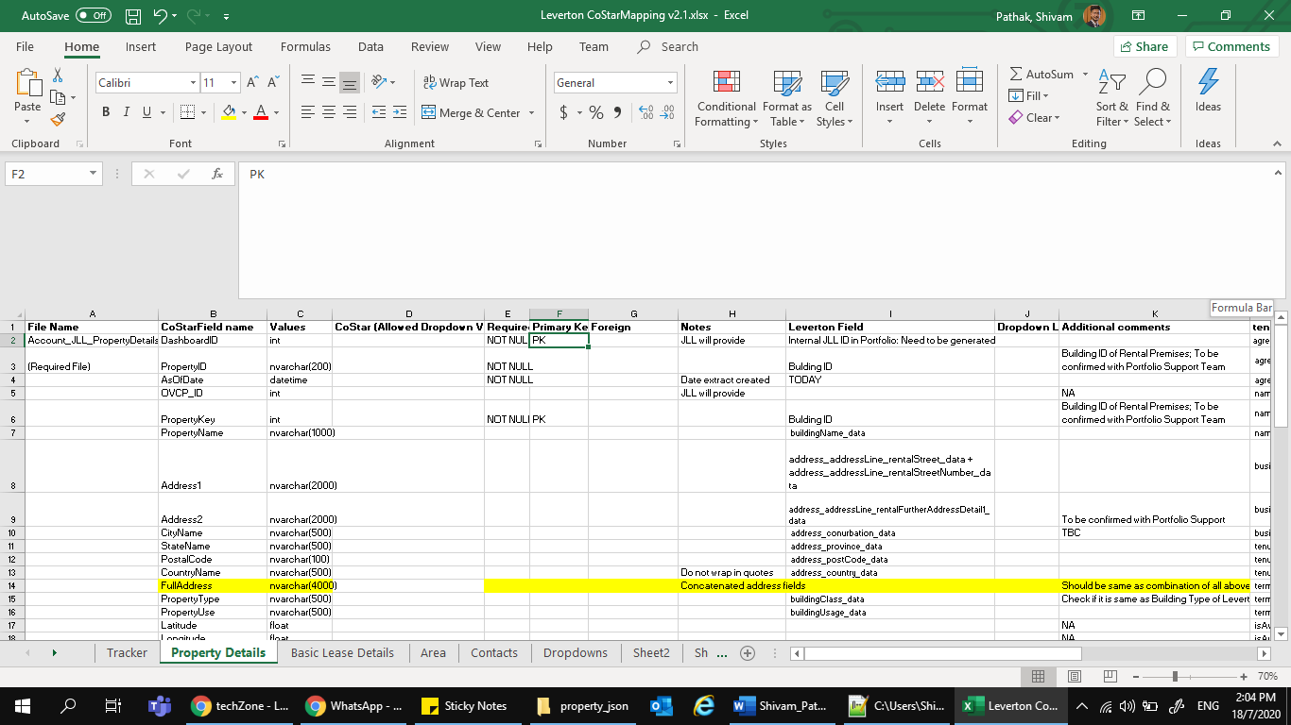
A mapping sheet is also provided for easy transition and understanding of data to the Data team. In fig 3.4, an example of the one of the many multiple files.

Fig 3.4 Example sheet for Leverton Files mapping with Altryx Tool
As can be seen, In fig 3.5 the process is given in the form of a table where JSON files are converted and stored in the final tables to get the data ready for the downstream application. Stored Procedures have been built and are functional at Portfolio program which is required to integrate business logic on various STG (Store, Transform, Group) tables.
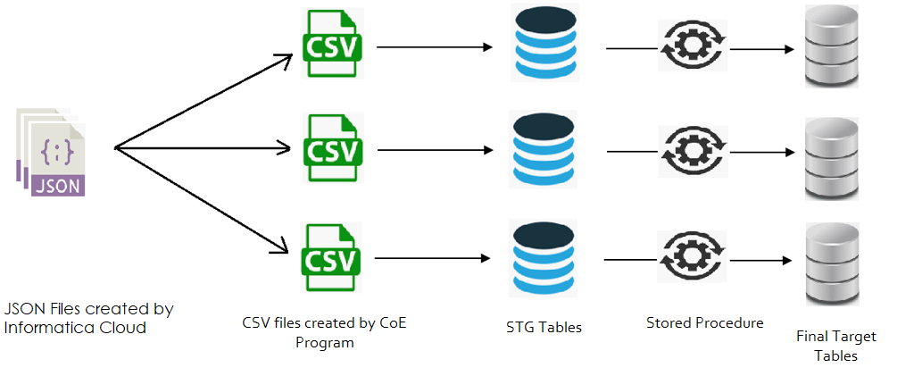
Fig 3.5 Extracting, transforming and loading the datasets into the data warehouse

The Fig. 3.3 shows process which includes the following activities:
- Extracting JSON file from the Altryx System.
- Converting it into the CSV file.
- Manipulating the data to load in into the Leverton Platform.

3.5.3 Final Target Table to Ready feed files
This process is to extract delta cut from final target tables which hold ready feed for downstream applications. The data is further taken and the data is extracted in the form of ready feed files which are feeded to the downstream applications as and when required by Business Teams of JLL. Fig 3.6 shows the block diagram of the conversion from final target table to ready feed files.
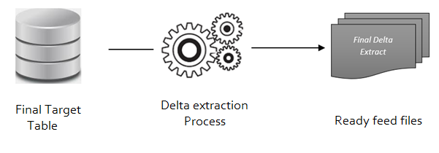
Fig 3.6 From final table to ready feed table
3.5.4 Building the Final Application
In the last process, the ready feed files will be transmitted to downstream applications as required. The automation has been designed to run on Python language[12]. But before we get to the automation part of the project, data needs to be extracted from Altryx platform and analyzed.

3.6 Extracting the Data
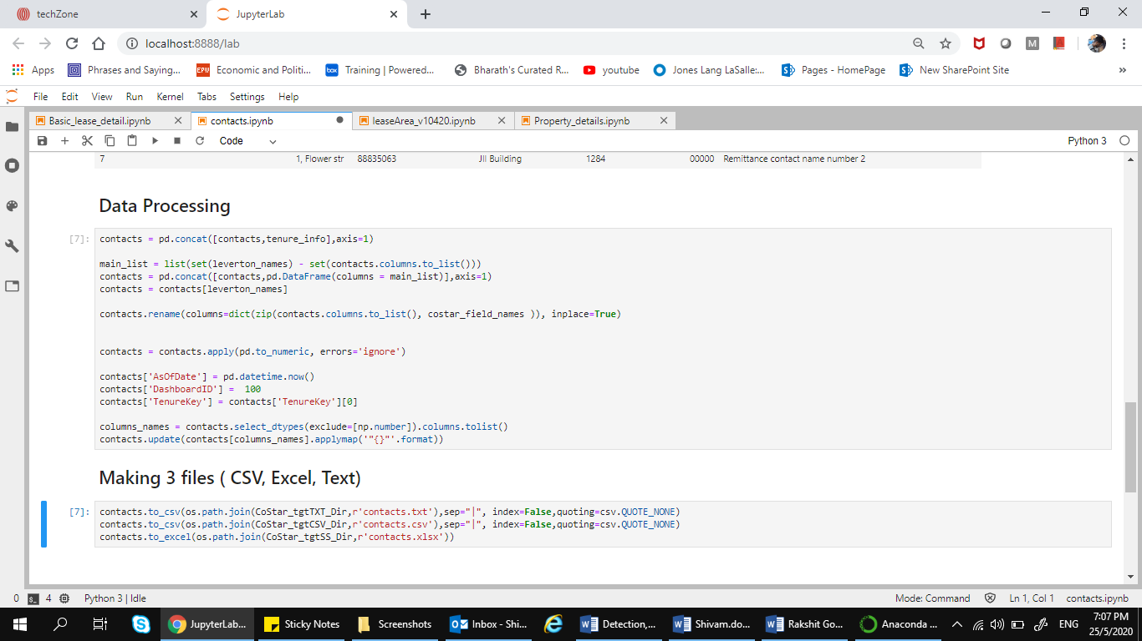
Figure 3.7 shows a snippet of the dataset which has been imported into the python environment and from here, the manipulation of dataset starts. The manipulation is done according to the requirement of the business to get the best desired output from the data. The data is then further exported into such a form so that it can be readily loaded into the Leverton Platform (or any other platform as required by the Business). The Leverton platform needs the data to be in CSV file with the delimiter ‘|’. For this, we convert the final data into a csv file and use the required delimiter as needed. The complete code journey was not allowed to be put into the report due to company policy and security concerns.[12]

Fig 3.7 Exporting datasets from python to multiple STG Tables

3.7 Integrating with ERP
We worked on an Enterprise Resource Planning (ERP) system – SAP where we worked on creating users and groups, building roles, assigning T Codes to the roles. Teams provide full-life cycle support of SAP applications, providing functional and technical capabilities. Capabilities include value focused managed services and augmentation services in support of application development and management, center of excellence, strategy and operations design, and design-build-operate for both on-premise and cloud-based Data Solutions.
3.7.1 Key Contributions to a project with SAP
a) Role Creation in SAP - Roles are created via PFCG t-code and when roles are generated, we get authorization profiles. These roles are added to users via SU01 or PFCG t-code. When they get added with proper validity period, the authorization profiles get assigned to users. A single role contains t-codes to give authorizations to users. A composite role is a business role that consists of multiple single roles.
Fig 3.8 Role Creation Login Pad of SAP (courtesy [8])

b) Role Maintenance - In transaction Role Maintenance (PFCG) you can configure roles. Transaction PFCG covers various aspects: the administration of authorizations and profiles as well as the definition of user menus. In real life, a role corresponds to the work that a person does within a company or the position held, for example, a real estate salesperson or someone working in support. In transaction PFCG, roles are defined matching the real-life roles that people play within a work situation. More specifically, a role within transaction PFCG is a set of transactions that persons within specific roles would need for their daily work. For example, a Real estate salesperson might have a role that requires transactions to add new customers, display customer details, or to enter a new lead.

Fig 3.9 PFCG role maintenance (courtesy [8])
3.7.2 System Landscape & Architecture
The system landscape is defined as an arrangement of JLL servers. Ideally, in an environment, a three-system landscape exists. A system landscape consists of Development Server (Dev), Production Server (PROD), and Quality Assurance server (QAS). The Architecture is defined as a technology framework of the system and it changes with time unlike the system landscape.
The following is a request in the System Landscape –
DEVELOPMENT >>>> Quality >>>> PRODUCTION

3.8 Deployment
In the deployment step, the server is used by the actual clients. The new interactions at this phase might reveal the new variables and needs for tweaking of the code. These new challenges could initiate revision of either business needs and actions, or the model and data, or both. This part is called feedback, and this ensures constant improvement in the deployed service.
To summarize, it is an iterative process and it is a cycle, and which never ends.

CHAPTER 4
RESULT ANALYSIS

4.1 Introduction
This chapter gives an insight on the data transferred from the Altryx platform to the Leverton Platform. It also briefly touches the data alignment from different sources into one source. It also explains the significance of these results.

  - Result
This feature has not been yet deployed and is under development. Figure 4.1 shows the final dataset that is ready to be loaded into the STG(Stage, transform, group) table. The STG tables are further needed to be shifted to applications, which is yet to be completed.
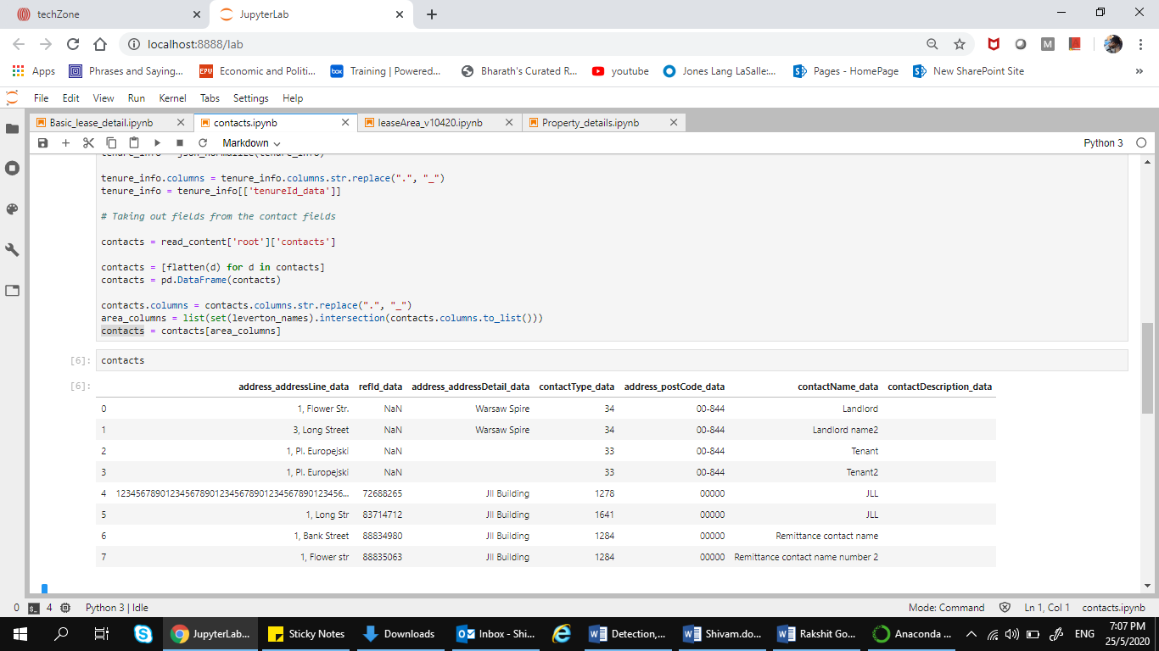
Fig 4.1 Importing datasets from Altryx Platform into Python environment

To discuss of the second part of the project, for the Cyber Risk offering, we created an entire organization management system for the business part of JLL to handle the daily grind of as many as even a million clients, by understanding the needs of the client, their organizational structure, the concept of big data, and the constant need for stronger security measures. We are also in the process to create an application from scratch as a part of the innovation project making use of the latest technology with minimal resource, time and cost utilization. Our project will further be taken up by the innovation space for development, testing and deployment.
- Secure solutions help clients invest in security controls and preventive measures, aligning investment with awareness of their key risks.
- Application Security solutions focus on embedding security into design to prevent costly rework and remediation later.
- Application Security solutions do this by working to “embed” security within the organization’s technology and processes, continuously monitor the environment and respond to events.
- Solutions address the security controls and measures to preserve the value of critical business and IT transformations and enable business performance

With IAM technology solutions, the managers of our external client can now control user access to information about their organization within their organizations. Identity and access management products have offered them role-based access control, which lets system administrators regulate access to systems or networks based on the roles of individual users within the enterprise. In this context, access is the ability of an individual user to perform a specific task, such as view, create or modify a file.

Roles are defined according to job competency, authority and responsibility within the enterprise. We also helped their systems include Single Sign-on (SSO), multifactor authentication. This helped us enable them with the ability to securely store identity and profile data as well as data governance functions to ensure that only data that is necessary and relevant is shared. That means that systems used for IAM have provided the client with a centralized directory service with oversight as well as visibility into all aspects of the company user base. In simpler words, we plan to achieve the following after the deployment of the project for our users:
- Improve audit performance by automating compliance controls and audit reporting.
- Manage the compliance using automated access certifications and policy management.
- Automate provisioning across the user lifecycle by simplifying processes for creating, modifying and revoking access.

4.3 Conclusion
This chapter talked about the various results which are aimed to be achieved during the project. These results prove that there is lot more work that needs to be done in the field to make the ETL process good enough to be deployed on the JLL Technology servers.

CHAPTER 5
CONCLUSION AND FUTURE SCOPE OF WORK

5.1 Brief Summary
This report summarizes the new ETL tool being developed by the Business Corporate Solution Team to streamline the flow of data. It defines the working, methodology and the expected results after the successful release of this new feature after testing it on Production Plane. The User Experience is a comprehensive measurement of the quality of the session established by the user while using JLL dashboards and tools. The client is supposed to have an easy understanding and insights from the data, and our work is to make the data as user friendly as possible to the business side of JLL.

As stated above, we used different data source for storing the client data payload, which was supposed to be in another data source. So, our main aim of focus was to streamline data transfer for other business clients of JLL as well.

As data in the Real Industry is not organized and clean, it required extra effort to process and store the data in the warehouse. Thus, further scope of work will be to build application at the initial stage itself which helps to streamline data.

Furthermore, the Asset management system will help in the following ways in protection and securing the data –
• Risk mitigation
• Revenue Generation
• Customer Service
• Process automation

The second phase of working on a live project to meet client deliverables was postponed due to COVID-19. In place of completing the deliverables, I was instead asked to take up another internal project on the topic of how to Balance Ethics and Technological Advancement in the Age of Data And AI.

5.2 Future Scope of Work
Organizations both small and big, are opening to the possibilities of data analytics and the amount of impact it can bring into organizations. They are also investing in Big Data and related technologies to make more informed decisions. Right from optimization of supply-chain systems and workflow management to enhanced customer experience and maintaining attrition, they are resorting to data. In fact, even a decision as simple as getting a coffee machine in a cafeteria is data driven. From all these observations, we can surely say that the future of data looks strong and undisputed.

With technologies like artificial intelligence, machine learning, and internet of things (IOT) also relying solely on Data, this is really the technology of the future. This technology is future- proof and the importance of it will only get finer and disruptive with time. So Data analytics will be the next future for every sector with the aim of increasing its productivity.

REFERENCES

- Alteryx.com. 2020. Self-Service Data Analytics Platform | Alteryx. [online] Available at: <https://www.alteryx.com/> [Accessed 9 March 2020].
- Leverton. 2020. Leverton Artificial Intelligence Platform | Data Extraction. [online] Available at: <https://leverton.ai/> [Accessed 4 March 2020].
- Docs.microsoft.com. 2020. Azure Documentation. [online] Available at: <https://docs.microsoft.com/en-us/azure> [Accessed 1 June 2020].
- aws.amazon.com 2020. Amazon AWS Documentation for Cyber Security [online] Available at: < https://docs.aws.amazon.com/IAM/latest/UserGuide/introduction.html>
- Informatica cloud Documentation, Available at <https://www.informatica.com/in/products/cloud-integration.html>
- Sajjad Rafique, Mamoona Humayun, Zartasha Gul and Ansar Abbas, “Systematic Review of Web Application Security Vulnerabilities Detection Methods”
- Vaibhav Sathe, “Literature Survey on Identity Management”
- Sap Modules, available at: <https://www.system-overload.org/sap/modules.pdf>
- Injazz J. Chen, and Karen Popovich, “Understanding customer relationship management (CRM): People, process and Technology,” Business Process Management Journal.
- Sérgio Moro, Raul M. S. Laureano and Paulo Cortez, “Using data mining for Real Estate.marketing: an application of the crisp-dm methodology”.
- Morteza Namvar, Mohammad R. Gholamian, Sahand KhakAbi, “A Two-Phase Clustering Method for Intelligent Customer Segmentation”.
- Anaconda.org[online] Available at: <https://anaconda.org/pandas> [Accessed 9 June 2020].
- Python.org. 2020. Welcome To Python.Org. [online] Available at: <https://www.python.org/doc/> [Accessed 4 March 2020].
- Spark.apache.org. 2020. Index Of /Docs. [online] Available at: <https://spark.apache.org/docs> [Accessed 9 May 2020].

PROJECT DETAILS

Student Details
Student Name | Shivam Pathak
Register Number | 160907344 | Section / Roll No | A/36
Email Address | Shivam.mit20@gmail.com | Phone No (M) | 8073800369
Project Details
Project Title | ETL Pipeline Design for Call Centre Customer service
Project Duration | 6 months | Date of reporting | 7.1.2020
Organization Details
Organization Name | JLL Technologies
Full postal address with pin code | Prestige Trade Towers, Centre of Excellence (COE), JLL Technologies, Vasant Nagar, Bengaluru,  Karnataka 560052
Website address | www.jll.com
Supervisor Details
Supervisor Name | Joseph Vinod Miranda
Full contact address with pin code | Prestige Trade Towers, Centre of Excellence (COE), JLL Technologies, Vasant Nagar, Bengaluru,  Karnataka 560052
Email address | JosephVinod.Miranda@ap.jll.com
Internal Guide Details
Faculty Name | Dr. Somashekara Bhat
Full contact address with pin code | Department of E & C Engineering,  Manipal Institute of Technology, Manipal
Email address | soma.bhat@manipal.edu

